# R1 task breakdown

24h Server setup of test reports and initial testing of sample reports

* Site administrator access to a AN test site
* Confirm embed URL model
* Confirm org filter operation
* Confirm security of reader vs contributor
* Confirm save-as only goes to correct project

16h Technical requirements buildout

* Final decisions about UI, and the corresponding embed URL
* Detailed model for REST API calls

8h Global settings

* New license setting for Tableau
* Setting for Tableau server URL (comes from ActiveNetSites; not editable)
* Setting for Tableau site name (comes from ActiveNetSites; not editable)
* Setting for site administrator user and password (comes from ActiveNetSites; not editable, decrypted)

8h Portal changes

* New edits for Tableau server URL, site name, site administrator user and password (encrypted)

4h User profile changes

* Tableau reader permission
* Tableau contributor permission

4h Report menu changes, with profile settings

* Initially hard-code menu settings
* All menu items displayed if user is Tableau reader or contributor

24h Report viewer

* Trusted authentication with correct user
* No filter capability
* Launch report with correct UI settings
* RServerLog recording

8h Get information from Tableau server at startup

* Call REST API to sign in as the site admin user, get security token
* Call REST API query ANet site by name get ID
* Call REST API to enumerate through users for site, to find org user by name and get ID
* Call REST API to sign out

16h Read published reports and update UI

* Scheduled execution every 5? min
* Call REST API to sign in as the site admin user, get security token
* Call REST API to enumerate through user’s workbooks
* Call REST API to enumerate through views for each workbook

16h Update Tableau reports table

* Store views into Tableau report table, keyed by view ID
  + If ID does not exist, create record, use view name, and assign to “domain” = project name
  + If ID does exist in table, unhide it
  + If a record in the table was not enumerated, delete or hide in enumeration
* Call REST API to sign out

# Preliminary model of ActiveNet/Tableau

## In user profile, user is granted permission to run the report

*Requirement 3.1.1: Report Level: As an administrator, I can define which reports can be viewed by specific users/groups…*

*Requirement 3.1.3: Managing Users: As an administrator, I need to set user access to specific reports based on existing Active Net credentials…*

*Requirement 3.1.4: Single Sign-on: As a user, I can seamlessly access all my reports without having to login to a second system so that I have easy access to ActiveNet reports.*

*Requirement 3.1.5: Use Existing Active Net user permissions: As an administrator I need to be able to configure all ActiveNET permissions in a single place*

The implementation model below and screen shots are based on the implementation in ActiveNet for integration with JReports.

At a high level, that model can be summarized as follows:

* Individual user profiles are granted permission to run individual reports through the same profile screen as all other permissions.
* These assignments are stored in ActiveNet’s DB.
* The profile of the logged in user controls which reports are displayed in the menu system and therefore can be executed by that user.
* A single user per org is created in JReports, because granular access control is not implemented there.

### User is assigned to a profile

A system user is assigned to one or more profiles:

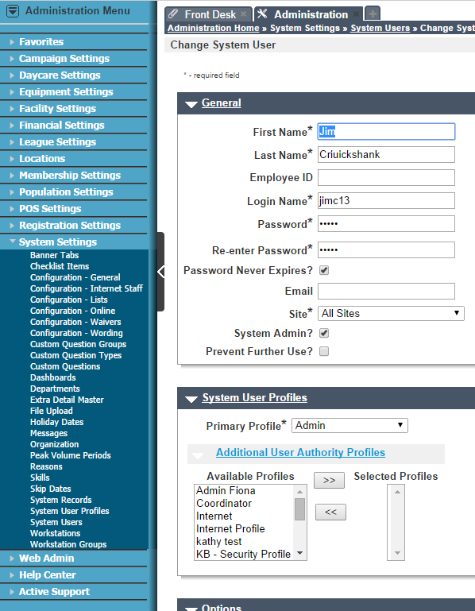

### Other types of report options

***Question for Tableau:*** When customizing a report in Tableau, if there is a data filter, is it possible to enter a date relative to today (e.g., today – 7 days)?

## Export report results

## Scheduling report distribution

*Requirement 3.3.1: Automated report emailing: As an administrator, I need to be able to automate the emailing of a pdf, xls, xlsx, png, or jpg version of the report...*

The Tableau functionality which seems to match is the ability to “subscribe” to reports on a schedule. This can be setup by a user through the Tableau report display, using the email link. This will display a small popup in which a user can configure the schedule and subject line of the emailing. However, there seem to be some functional gaps in the implementation:

***Question for Tableau:*** The documentation on subscription only indicates PNGs can be emailed. This might be fine for dashboards, but not for the types of report outputs our customers are accustomed to distributing via email, such as PDF. Is it possible to email the other data types?

***Question for Tableau:*** The documentation on scheduling doesn't seem to give a choice of email address; it's only the address associated with the Tableau user. Can we change the target email when setting up a subscription?

***Question for Tableau:*** Can multiple subscriptions be setup for a single view or workbook? It is currently possible to setup different saved report definitions, sending emails/FTPs on different schedules.

*Requirement 3.3.2: Schedule Report to FTP: As a user, I need a scheduled report to be exported to an FTP site, so that the report can be communicated to non-system users.*

***Apparent gap with Tableau:*** .No scheduled FTP capability seems to exist. If it were possible to schedule an export to a specified UNC, it might be possible to implement the report portion in Tableau, and the FTP portion in ActiveNet, although this could be awkward to configure.

*Unstated requirement: As an administrator, I need to be able to restrict which users are able to schedule report executions via email or FTP.*

***Question for Tableau:*** Is there any way to control this from Activenet?

* Can we disable the “email” link via the embed URL.
* Alternatively but less desirably, can we disable the email link via a user role which allows users to customize reports but not subscribe.

## Customizing reports

*Unstated requirement: As a user, when I modify a view and use the "Remember" feature, it will not be visible to users of other organizations.*

According to Tableau:

“By default your custom view is private and only you can see it on your list. If your license level is Interactor, you can choose to advertise it to others.”

Therefore, this requirement will therefore be satisfied if we can disable the advertising feature.

***Question for Tableau:*** Is there any security setting on a user which would allow it to make changes to a view, save those changes, but not advertise them.

***Question for Tableau:*** If this isn't possible, could it be implemented with the site mechanism, so each organization would have a site with one user? Would this prevent the advertising of views cross-site?

*Unstated requirement: When a user modifies a view and uses the "Remember" feature, the new view should now show up in ActiveNet's report security system.*

Based on the following answer from Tableau, it appears that it is possible through the Javascript API

? After a customized view is saved, will it show up in the REST API in the "Query views for workbook" method (or anywhere else we can get to it)?

*Unstated requirement: If a workbook is published to the production Tableau server, then a user creates a custom view for that workbook, then an updated copy of the generic workbook is published to production; do custom views which had been created still exist?*

Based on the following answer from Tableau, it appears this will work (but we need to confirm):

“I opened the workbook from the server, made changes, saved it locally, published it back to the server using the same name.  I was prompt to overwrite the workbook on the server, I click OK, and it is uploaded.  When checking the server, the custom views are still there.  So it appears we would be fine and that the Custom Views are saved on the server, not with the .TWB file and are not overwritten.

*Unstated requirement: As an administrator, I should be able to restrict which users are able to save customized reports.*

This appears to be possible to control from ActiveNet through the embed URL, by including &:customViews=no (or yes).

## Customizing terminology

*Unstated requirement: Within a view, we need to be able to change the names of columns and filters, based on configured renaming in the application database. E.g., the generic ActiveNet term "Activity" is configurable, so it might be called "Class" or "Camp"; this terminology override is stored in a table in ActiveNet.*

***Apparent gap with Tableau:*** Is it possible through the JS API or some other means to change terminology in the view being displayed?

A: As for the Columns question; looks like the API supports getting properties of the fields in the data source, but not setting them. See “Field Class” in http://onlinehelp.tableausoftware.com/v8.1/server/en-us/help.htm#js_api_ref.htm.

## Deployability

*Unstated requirement: As a report creator, I must be able to develop and test a report in a development environment, and export it as a file to commit to the version control system (SVN). The deployment system must then publish that report to the target environment (e.g, production), so that the report is listed in ActiveNet, and can be executed.*

The Tableau desktop provides the ability to save and load data sources as .TDS files, and workbooks as .TWB files. This should allow transporting them between environments, and saving these representations in SVN.

As I understand it, the publishing is currently a manual process. This might be acceptable if it needs to be done only once per release. However, if we need to use the Tableau site system to prevent Advertising, we might need to publish once per org, or assign permissions once per org user. In this case, automation is necessary.

***Question for Tableau:*** Is there any API which can be used to publish a workbook programmatically to a Tableau server, for a specific site or user?

*Unstated requirement: As a report creator, I must be able to control how a report appears in the ActiveNet menu system, and possibly what filter page is associated with it.*

It should be straight-forward to record this configuration information in an XML file which is part of the release image, and have the deployment system update the Tableau reports table in the org database from that information.

# Technical questions

User group administration

Label customization

Site filter

How to login as Tableau user to Tableau

# Tableau functionality to confirm

## High level

### Admin automation

#### Create a site for an org, and a user for that

Tabcmd login –s <server> -u <superuser> -p <pwd>

Tabcmd createsite <AN-org> -r <AN-org>

Tabcmd createusers “users.csv”

Tabcmd login –s <server> -t <AN-org> -u <superuser> -p <pwd>

Tabcmd createsiteusers “siteusers.csv”

#### Create a workbook from a TWB file (must be automated)

Tabcmd login –s <server> -t <AN-org> -u <superuser> -p <pwd>

Tabcmd publish “<workbook name>.twb” –db-username “dbuser” – db-password “pwd” -o

### Execute workbook view via URL and display

#### <http://qa-aci-tab-vip.dev.activenetwork.com/views/TopNFacilitiesbyOrgandSite/TopNFacilitiesbyOrgandSite?:embed=no&:customViews=no&:format=xlsx>

#### :embed=yes& – Hide the heading

#### :customViews=no& – Hide the “Remember my changes” drop-down

### Execute workbook view via Javascript and display

### Execute workbook view for just a single org’s data

#### Embed: Org Name=Auburn&

#### Org Name= Anchor Bay School District&

### Execute workbook view for just a single org’s data, with other filters

#### Embed:Sitename=Internet,BLOCK& (one or more values)

#### &Sitename=& (if no values, to clear any filters)

### Export workbook view to PDF

#### Embed: &:format=pdf

### Export workbook view to CSV

#### Embed: &:format=csv

### Export workbook as an image

#### Embed: &:format=png

### Print workbook

#### Print PDF

### Report URL cannot be used to execute reports outside AN

#### Trusted authentication

### Control which AN users can customize reports

#### Embed: &:customViews=false

## Critical ones still to figure out

### Display any customized reports within application

### Schedule a workbook view execution to email any of the export options

#### Would have to be created within Tabeau, not ANet, as a subscription

#### “Subscription” feature in Tableau 8.0 appears to be limited to .PNG exports (CSV and PDF not supported)

#### Appears from screen shot that the org user would have a single email address

#### Not sure if we can limit who can schedule exports

### Customize labels in report based on configured terminology

### Does updating a workbook in prod overwrite custom views?

### Org logos

### Passing ID lists into Tableau

## Specific report filter / option types

### Date range

### ID lists

## Other

### Terminology configuration

# Security questions

## View-level permissions

### Want to maintain this control in ANet, like existing canned and adhoc (JReport) reports

### Won’t need Tableau users for individual users

### Won’t need SSO

## In report tested, filters always are displayed. Not good, especially since there is an org filter

### Can we enable or disable specific filters on the report?

### Is this related to the license viewer vs. interactor level?

### Do we want Tableau’s filters to display?

### We don’t want org filter to display ever

## Org selection

### User filters to select orgs

## Trusted authentication

### To use trusted authentication, does the servlet already have to be authenticated with Tableau?

### If servlet loads a report page, how is a Tableau user assigned?

## Report customization (“Remember my changes”)

### Customized reports only for current org

## Should site mechanism be used for applications?

## Data security

### NT Integrated, run-as user

### ? Not using extracts

## HTTPS for client/server communication

# Implementation-specific questions

## How to email reports to certain AN users which aren’t Tableau users?

# General Questions

## How can we safeguard orgs so that only that org’s data is displayed?

## Tableau

### How do we setup data sources?

### Can I use the embed URL to display reports?

## What kind of test environment will we have?

## Do we need to do extracts?

# Status reports

## Need DB & Tableau credentials

## Site usage – currently is default site

## Publishing model

# To Do

## Review report specs

## Go through JReport cubes looking at the parameters, functions, etc.

## Go through AN looking at filter pages

## Look at .TWB XML format

## Look at .TDS XML format